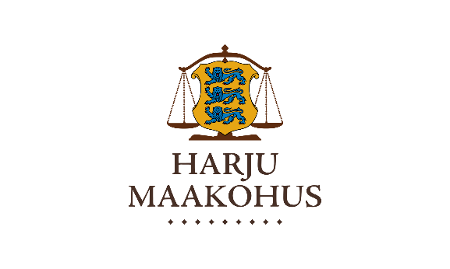

Dear Sir/Madam

|  |  |
| --- | --- |
|  | 26.03.2025 nr 9-7/25-73-1 |

|  |  |
| --- | --- |
| Certificate |  |

Harju County Court (Harju Maakohus, registry code 7400l 728) hereby confirms that Kertu Altin (personal identification code 49201232746) is working at Harju County Court as a clerk since March 12, 2018 for 40 hours a week with the monthly gross salary 2 847 euros.

Sincerely

Astrid Asi

president

of the Harju County Court